39.67: a) 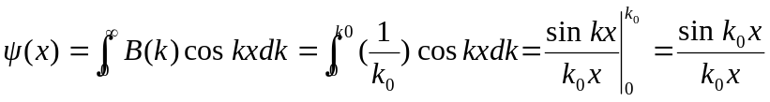
b) 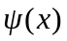 has a maximum value at the origin 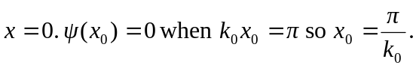Thus the width of this function 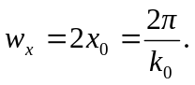
If 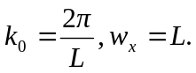
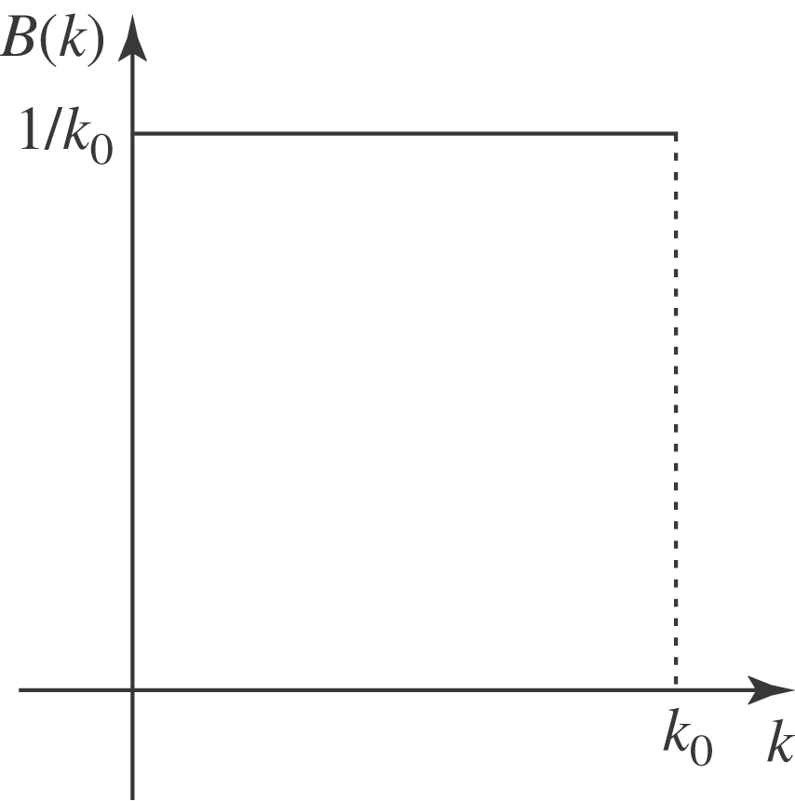
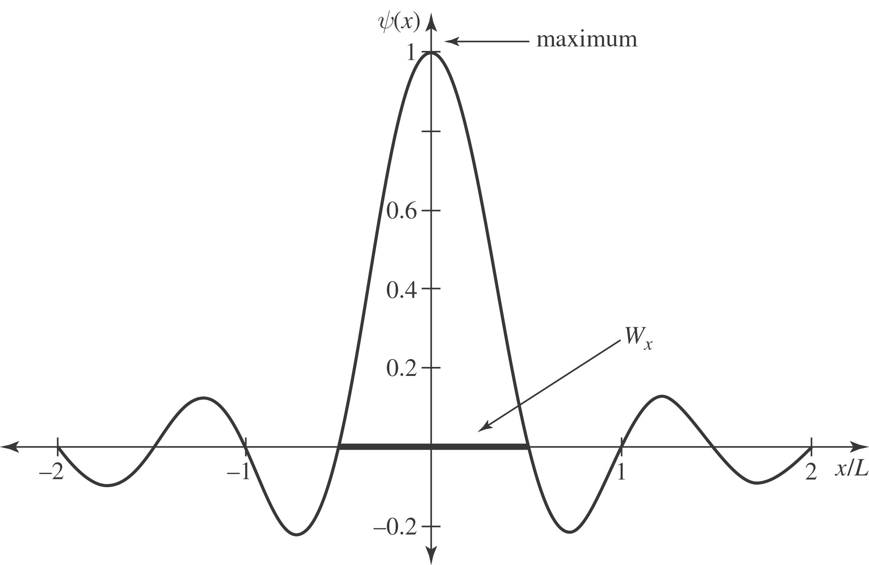
c) If 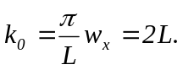
d) 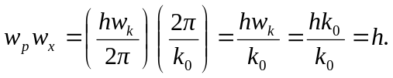
The uncertainty principle states that 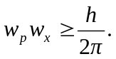 For us, no matter what 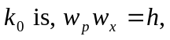which is greater than 